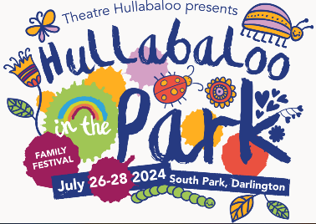
Access Guide for
Hullabaloo in the Park 2024

Included in this pack:

How to get in touch with us 2
Festival Information 2
Dates the festival is running 2
The overall festival times 2
Festival Event Staff 2
Getting there 3
Information Point / Hullabaloo Hub 3
First Aid 3

Accessing the festival 4
Disabled parking 4
Wheelchair access 4
Accessible toilets 5
Assistance dogs 5
Ear Defenders and Sensory Equipment 5
Distances between ‘Stages’ 5

Programme Information 8
British Sign Language (BSL) Interpretation 8
Non-Verbal performances and activities 9
Neurodivergent friendly performances and activities 10
Waiting times and queues 13
Visual Stories 14

How to get in touch with us

If you would like to speak to someone about your access needs for the festival, you can:
- email us at info@theatrehullabaloo.org.uk

- call us on the Theatre Hullabaloo office on 01325 405680 between 10am and 4pm Monday to Friday, before Friday 26 July 2024.

- call us on the Festival Access Phone Number – 07946 072131 between 9.00am and 6.00pm Friday 26 – 28 July 2024

- Text us on the Festival Access Phone Number – 07946 072131 and we will reply between 9.00am and 6.00pm Friday 26-28 July 2024

__________________________________________________________________

Festival Information

Dates the festival is running

Friday 26th July, Saturday 27th July and Sunday 28th July 2024

The overall festival times

Friday 26th July 10.30am until 4.30pm
Saturday 27th July 10.30am until 4.30pm
Sunday 28th July 10.30am until 4.30pm

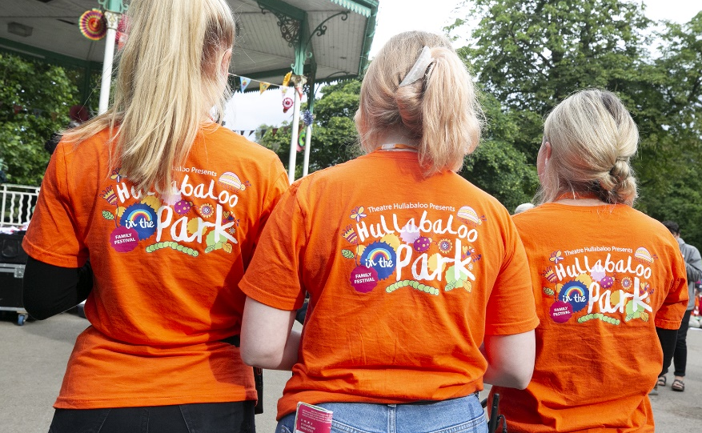

Festival Event Staff

All Festival Event Staff will be wearing either Orange T-shirts. They can answer any questions you have and help you find activities.

Getting there

South Park is in Darlington.
There are several entrances to the park, however there are two main entrances to the festival activity.
- Parkside Entrance (use postcode DL1 5TG) (What3Words: pink.hulk.quick)
- Victoria Embankment Entrance (use postcode DL1 5JS) (What3Words: trunk.speeds.font)

Information Point / Hullabaloo Hub

There will be an Information Point near both entrances where you can get all of the information you need about the festival. This will be a Theatre Hullabaloo branded white gazebo. Come and see us if you have any questions or need help.

There is a designated lost child point at both Information Points.

First Aid

There is a First Aid point at the Victoria Embankment End, near the Information Point (Map reference 15). If you feel unwell, ask the first aiders to help you.

__________________________________________________________________

Accessing the festival

Disabled parking

Blue badge holders should follow the usual guidelines around parking, and it is the responsibility of the badge holder to park appropriately.

There are some disabled parking spaces at the Parkside Entrance to the park. As a blue badge holder, you may be entitled to park on the double yellow lines outside of all entrances to South Park providing there are no loading restrictions in that area, allowing you to park here for up to 3 hours when displaying the time clock and badge. Blue badge holders cannot park in loading/unloading bays.

Parking

There is limited car parking around South Park so we have organised a dedicated festival car park just around the corner at Darlington Rugby Club, Grange Rd, Darlington DL1 5NR. (What3Words: insist.city.waddle). For just £5 a day you can park your car and then access the park via the Parkside entrance.

There will be a security team at the car park but Theatre Hullabaloo assume no responsibility for loss or damage to personal property. The security team will be in attendance from 10am-5pm.

Upon arrival a car park attendant will ask to see your booking confirmation on your phone and then you will be able to choose a car parking space.

Please follow this link to book your car parking.

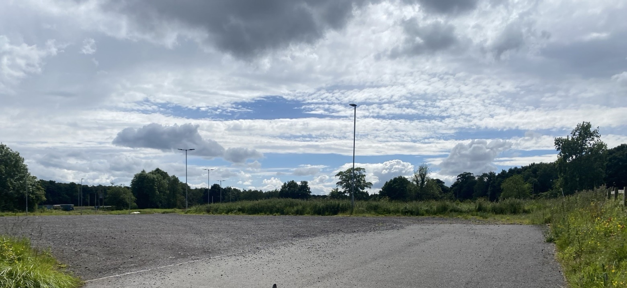
The carpark
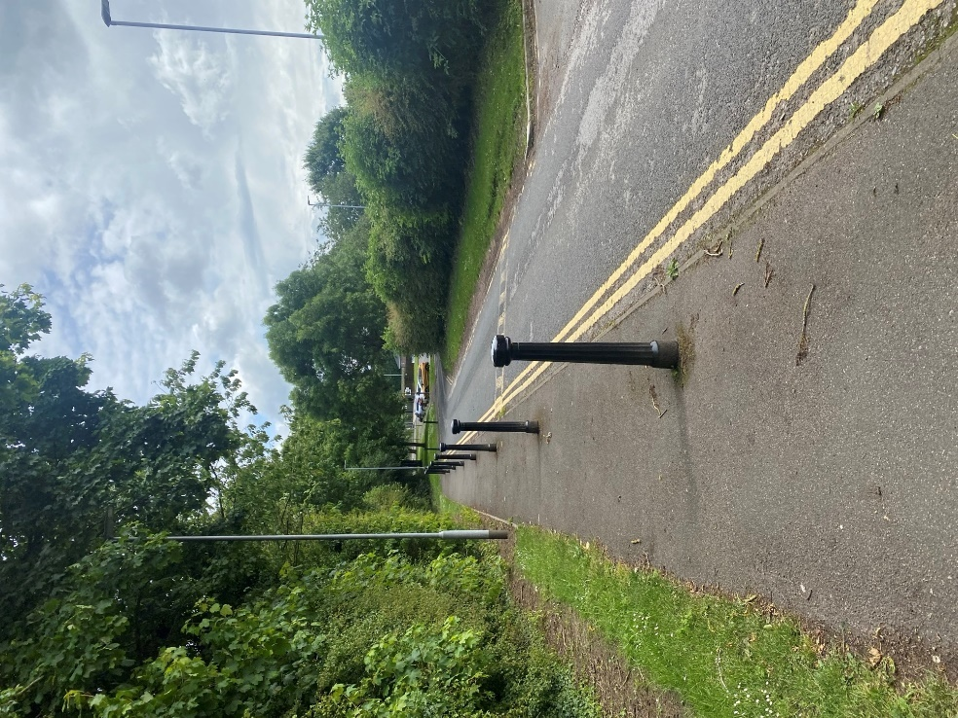
Entrance/Exit walkway from/to the festival.

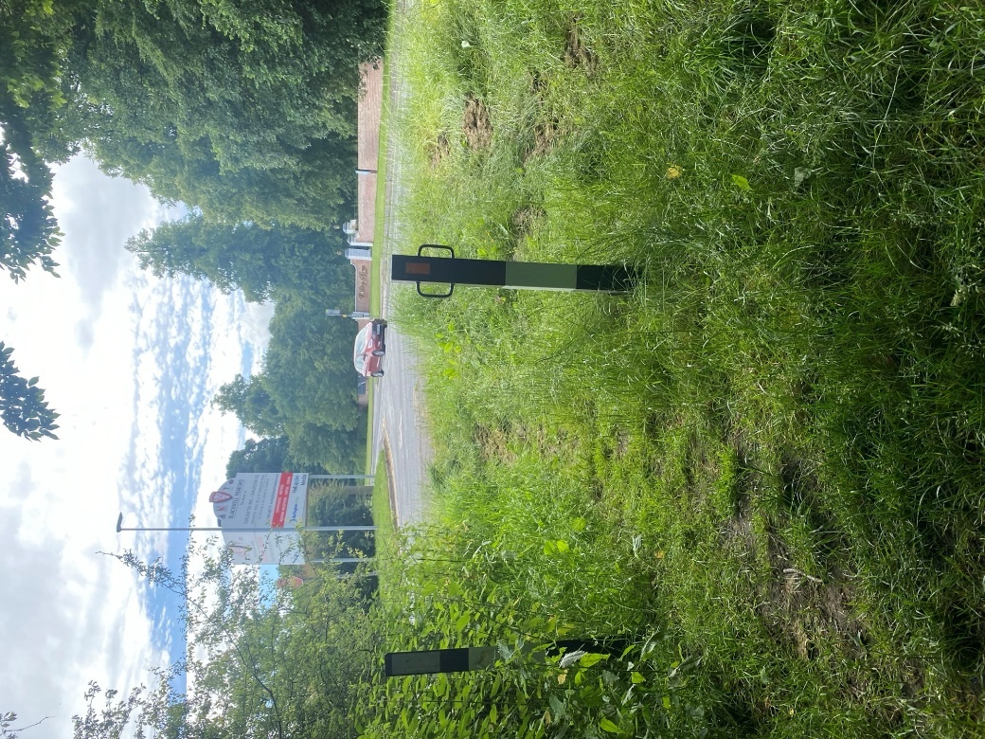
Entrance to river walk leading to the festival
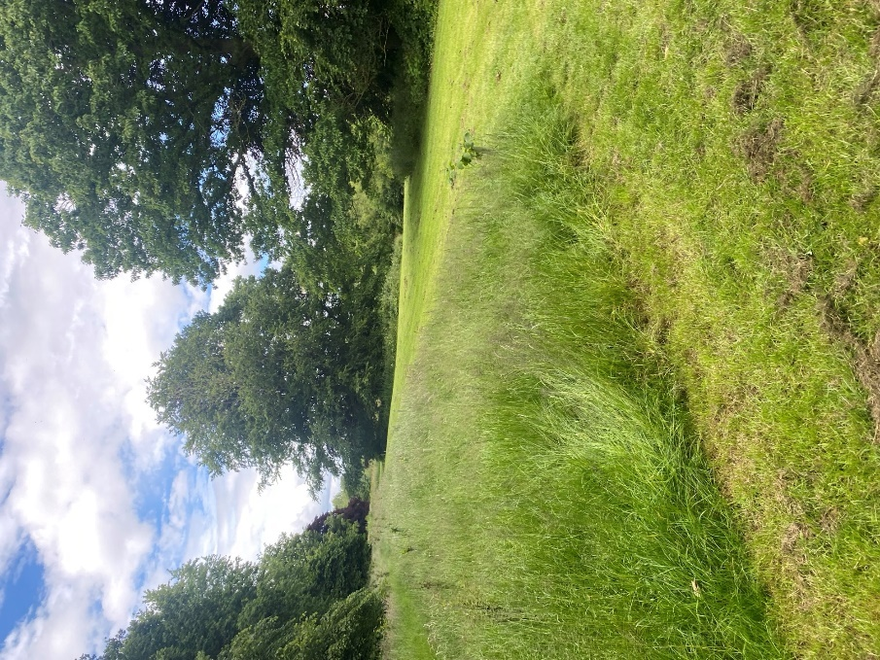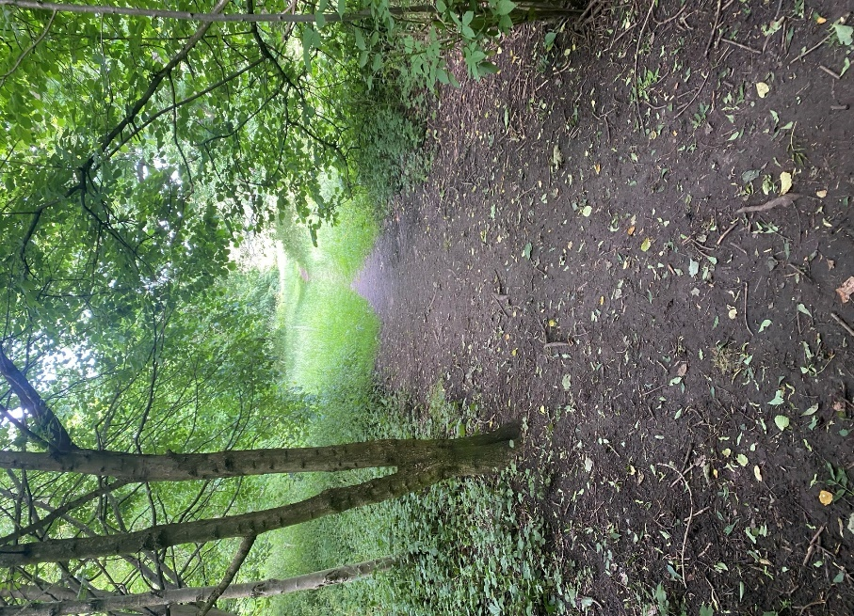
Route to the festival across parkland.

If our dedicated car park is fully booked then we recommend you use the town centre car parks and access the park by foot through Victoria Embankment. There will be an Information Point in this area or you can walk to the Information Point near the clock tower / café area. Both Information Points will have festival maps and details on what’s on each day.

Wheelchair access

All of the performance spaces (“stages”) can be reached by a wheelchair via well maintained concrete paths all the way around the park. The Parkside Information Point (reference 1 on the map) is right next to the concrete path. The Victoria Embankment Information Point (reference 15 on the map) will have matting on grass to support wheelchair access.

The accessible step-free routes (for wheelchairs and buggies) have been identified on the Festival Map but if you are unsure, just ask one of our lovely festival staff members and they can assist you. It may take longer to use the step-free routes around the park, so you may need to allow for a little extra time to arrive for a performance or activity.

There are some gentle slopes on the step free route shown on the map.

Although the paths leading to all stages are wheelchair accessible, the performance spaces themselves are all on grass. There will be plastic flooring near the Food Vendors and the Family Picnic Areas shown on the Festival Map so these spaces will be accessible to wheelchair users.

You can see images and videos of all performance spaces in this Google Drive Folder. https://drive.google.com/drive/folders/14YSAxOIyn4fFieE64UoeKzR_Hfhv3-5D?usp=drive_link

All activity on the Spider Stage is accessible to wheelchairs as it will be visible from all concrete paths in that area and there will be no need to move on to the grass for this stage.

Accessible toilets

South Park and all of the permanent facilities within it are managed by Darlington Borough Council. This includes the toilets and café. There is one ungendered accessible toilet in the toilet block near the White Clocktower, and you may need a key from the café to access this.

In addition to the toilets provided by the council, there will be portaloos available for people attending the festival, including a wheelchair-accessible toilet. These toilets will be towards the Victoria Embankment entrance. See the map for more information (reference 25 on the map).

The nearest ‘Changing Place’ toilet is situated on the ground floor at the Dolphin Centre which is within Darlington’s Market Square.

Assistance dogs

Assistance dogs are welcome across the whole festival. If you need any more information on potential triggers for an assistant dog (for example food, puppets, loud noises), please see a member of the festival staff team on the day or contact us on the Festival Access Phone Number – 07946 072131

If you want to contact us in advance, email us at info@theatrehullabaloo.org.uk or call us on 01325 405680 (between 10am and 4pm).

Ear Defenders and Sensory Equipment

We will have a limited number of ear defenders and sensory equipment available to borrow from each Information Point (map reference 1 and 15).

Distances between ‘Stages’

If you are attending a specific event, we recommend leaving at least 15 minutes to get to the activity/performance to allow enough time to find which space the activity is taking place in.

Here are the timings and distance to get to from each entrance. Please note this is only a guide and it is likely to take longer if you have children with you. Below: Parkside entrance to Spider stage in the centre of the festival: Approximately 4 minutes (0.2miles) using the step free access route.

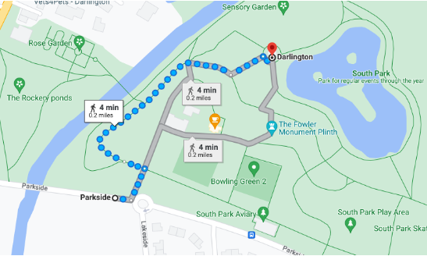

Below: Victoria Embankment to Spider stage in the centre of the festival: Approximately 4 minutes (0.2miles) using the step free access route.
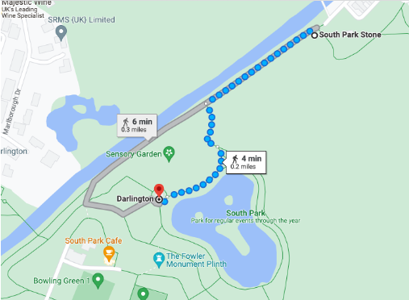

Below: Parkside entrance to Victoria Embankment entrance – whole length of festival/park: 7 minutes (0.4miles)
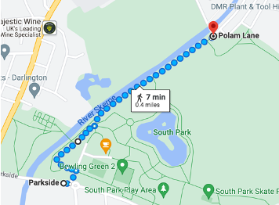

Programme Information

British Sign Language (BSL) Interpretation

We will have a BSL interpreter at the festival on Friday 26 July and Saturday 27 July 2024. They will be supporting a range of activities in the festival programme. These are:

- Sing & Play with Bridie Jackson – Friday 26 July at 10.30am & 11.30am
- Craft workshop – Friday 26 July at 12.15pm
- The Wishing Tree – Friday 26 July at 2.15pm & 3.45pm
- Giant’s Picnic – Friday 26 July at 3pm

- Wilding Workshop – Saturday 27 July at 10.30am
- Come Rain or Come Shine - Saturday 27 July at 12pm
- Sing & Play with Bridie Jackson – Saturday 27 July at 2.00pm
- Giant’s Picnic – Saturday 27 July at 2.30pm
- Hullabaloo in Wonderland – Saturday 27 July at 3.45pm

If you would like to make us aware that you will be attending a specific session, we can try to reserve a place for you if you need BSL. Please email us on info@theatrehullabaloo.org.uk or call 01325 405680 before the festival.

We also have one staff member who speaks BSL at Level 2 based at one of our free drop in craft tables (Snail or Mouse). They will be wearing a big badge to identify themselves. You can call or message our Festival Access Phone Number – 07946 072131 - to find out where they are that day.

Non-Verbal performances and activities

There are also shows and activities in the programme that are largely, if not fully, non-verbal, allowing D/deaf or hearing-impaired audiences to join the experience as well as those where English is not a first language.

These shows are:

The Weather Machine
100% Non-Verbal
Follow this link to find out more: https://www.theatrehullabaloo.org.uk/shows/hitp24-the-weather-machine/

Early Weaves
100% Non-Verbal
Follow this week to find out more: https://www.theatrehullabaloo.org.uk/shows/hitp24-early-weaves/

Hannabiell and Midnight Blue performance
Non – Verbal (All Music)
Follow this link to find out more: https://www.theatrehullabaloo.org.uk/shows/hitp24-hannabiell-midnight-blue/
Please note that this activity begins with a making workshop which will be lead verbally (approximately 20-30 minutes), followed by a musical performance (approximately 20-30 minutes)

Boxville
30% non Verbal
Follow this link to find out more: https://www.theatrehullabaloo.org.uk/shows/hitp24-boxville/

BubblePlaY
Mostly non-verbal
Follow this link to find out more: https://www.theatrehullabaloo.org.uk/shows/hitp24-bubbleologist-jesse-ward/

Slinkies
100% Non-Verbal
https://www.theatrehullabaloo.org.uk/shows/hitp24-theslinkies

Neurodivergent friendly performances and activities

Although we hope the festival will be accessible to all, we do have specific “neurodivergent friendly” performances and activities where families with additional needs might feel more comfortable.

The performance or activity will not have been changed from the standard version, but by identifying it as “neurodivergent friendly” we hope to provide an inclusive environment where parents and families feel comfortable in that space no matter what their needs. This is because, in theory, every family in that performance has experience with neurodivergent people in some form and may be more familiar with the behaviours within these families e.g., more noise or movement.

Anyone is welcome to watch any show or take part in activity that they feel is suitable for them and their family. If they have a neurodivergent child, they do not have to attend the identified “neurodivergent friendly” performance/activity.

We know from families that engage with us at The Hullabaloo that one of the barriers to attending activities with a neurodivergent child is often around having a specific time to arrive and participate in an activity. For this reason, we have identified bookable slots for some of our activities to allow you to plan your visit.

You can book tickets for these sessions on each of the show pages on our website. The tickets are free and everyone in your group needs a ticket.

The neurodivergent-friendly activities in the 2024 festival programme are:

Giants Picnic – Play Installation for 0- 5 years (Grasshopper Stage)
Follow this link for more information:
https://www.theatrehullabaloo.org.uk/shows/hitp24-giants-picnic/

Fri 26 July 10.30am – 11.15am
Sat 27 July 3.30pm – 4.15pm
Sun 28 July 10.30am – 11.15am

For the neurodivergent friendly group sessions for our Giant’s Picnic, we’re offering a 45-minute slot on each of the days which enables up to 4 families (where at least 1 person in the family being neurodivergent) to enjoy an adapted session.

The adaptations in this case are:
- reduced numbers
- a fixed 45-minute time slot
- and a specific staff member to support this session.
Because this is a group session, it is likely to mean that the session includes groups of people who are familiar with each other, so you can investigate the space in your own time.

Craft Workshop – (Worm Stage)
Follow this link for more information:
https://www.theatrehullabaloo.org.uk/shows/hitp24-crafts/
Friday 26 July 2.30pm to 3.15pm
Sunday 28 July 12.00am to 12.45am

Weave – Play Installation for 0- 2 years (Butterfly Stage)
Follow this link for more information: https://www.theatrehullabaloo.org.uk/shows/hitp24-weave-ndf-bookable/
Friday 26 July 10.30am to 11.15am
Saturday 27 July 3.30pm to 4.15pm
Sunday 28 July 10.30am to 11.15am

For the neurodivergent friendly group sessions for Weave, we’re offering a 45-minute slot on each of the days which enables up to 4 families (where at least 1 person in the family being neurodivergent) to enjoy an adapted session.

The adaptations in this case are:
- reduced numbers
- a fixed 45-minute time slot
- and a specific staff member to support this session.
Because this is a group session, it is likely to mean that the session includes groups of people who are familiar with each other, so you can investigate the space in your own time.

This activity is aimed at very young children so we expect the neurodivergent person in this group to be an adult.

Hullabaloo in Wonderland Leading on to Tea Party – (Meet at the Starting Point shown on the map)
Follow this link for more information:
https://www.theatrehullabaloo.org.uk/shows/hitp24-hullabaloo-in-wonderland-ndf-session/
Saturday 27 July 3.00pm to 3.45pm

The adaptations for the neurodivergent friendly session of Hullabaloo in Wonderland are:
- reduced numbers (approximately 25 instead of 40 seated at the tea party, adults can stand behind)
- a specific staff member to support this session.

Clay Critters by Bright Woods Forest School (Mouse Stage)
Follow this link for more information:
https://www.theatrehullabaloo.org.uk/shows/hitp24-clay-critters-ndf-sessions/
Saturday 27 July 12.45am – 1.15pm
2.00pm – 2.30pm
The adaptations for the neurodivergent friendly sessions for Clay Critters are:
- reduced numbers (up to 8 participants instead of up to 15)
- a specific staff member to support this session.

In addition to the specific neurodivergent-friendly sessions listed above and marked on the website, we hope that families will find a range of activities at the festival to entertain them at an appropriate level.

If you want any further information on any of our shows to be able to decide if the show is suitable for your young person, then please get in touch with us at 01325 405680 or info@theatrehullabaloo.org.uk and we can have a further discussion.

Waiting times and queues

We understand that it can be difficult to wait and queue with your young people, so if you turn up to an activity that is busy and currently has no more room, the staff member there will be able to advise on the next available time. You will then be able to go away and enjoy other areas of the festival and return back at that given time, rather than standing in a queue. If you would prefer to wait, you may do so.

Information on potential triggers

We know from working with families at The Hullabaloo that some of the content in shows and activities could be a potential trigger for a neurodivergent or disabled person so we would like to share more information with you on what these potential triggers could be across the programme.

Show / Installation / Event | Potential Triggers | Age Guidance
Boxville | Puppets – Made from cardboard including dragons and crab robots.  Dragon will Roar | 4 – 10 years
The weather Machine | Thunder Clap in the soundscape | 0 – 10 years
Wilding | Sudden Loud noises This is within the soundscape, more than once.  Puppets – some large including a barking dog. | 5 – 9 years
Hannabiell & Midnight Blue | Loud Noises – Brass instruments and Percussion | 0 – 10 years
The Flowering Tree | Sudden Loud Noises, Some loud percussive instruments. | 6 – 10 years
The Forest Dream: Storytelling & dance workshop | Seed activity uses wild seed and soil | 6 – 10 years
Tales from far far away | Puppets – characters from the story i.e. a snake. | 2 – 7 years
The wishing Tree | Puppets – following the story of the show. | 2 – 7 years
Sing and Play with Bridie | Puppets – small puppets with songs. | 0 – 4 years
Clay Critters | Natural materials will be used such as sticks and leaves, these can be avoided individually on request. | 2 – 10 years

Visual Stories

For available Visual Stories click on the links below:

Boxville:
https://www.theatrehullabaloo.org.uk/wp-content/uploads/2024/04/Boxville-Visual-Story-Guide.docx

Wild Child Messy Play:
https://www.theatrehullabaloo.org.uk/wp-content/uploads/2024/05/Wild-Child-Messy-Play-storyboard-2.png

