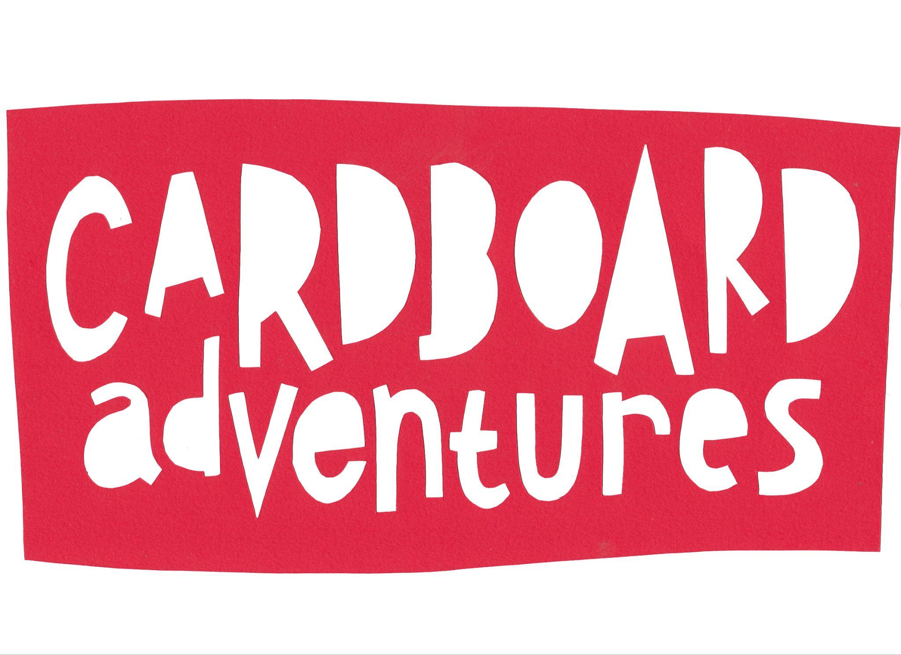

**Boxville Visual Story Guide**

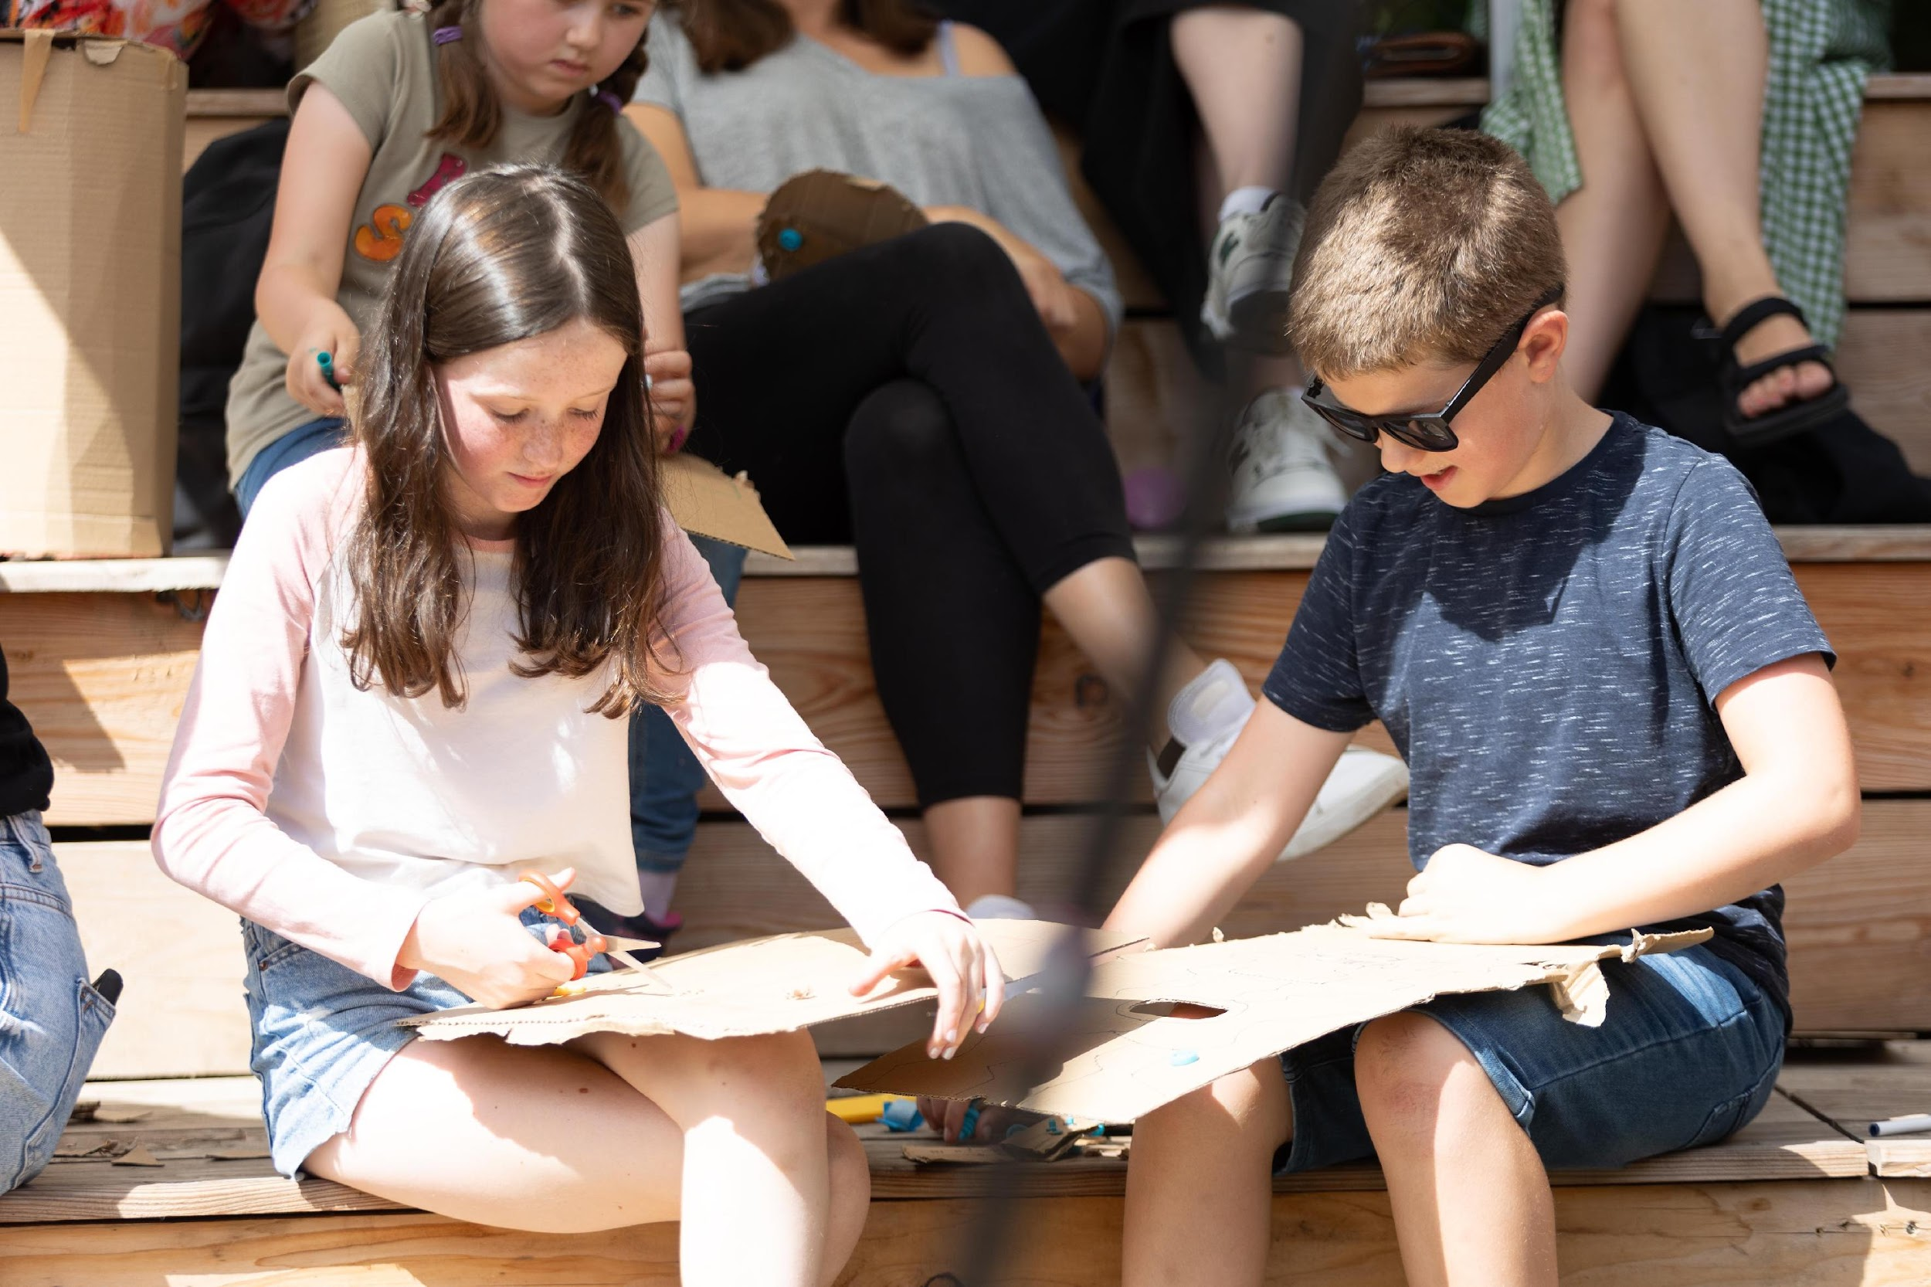

**What can I expect?**

|  |  |
| --- | --- |
|  | Boxville is about creativity and making things! |
|  | It is about 1 hour long. |
|  | You can expect to watch performers tell a story.  You can expect to make things from cardboard.  You can expect to play some games to help the out the characters.  You can join in with making things and playing games.  Or you can choose not to join in.  It’s up to you. |
|  | Sometimes there will be loud music.  Sometimes the characters will ask you and other people to make lots of noise. |

**What happens?**

|  |  |
| --- | --- |
|  | Boxville will start with Hedy, George and Ada saying hello.  Hedy, George and Ada are engineers and inventors! |
|  | They explain:   * They really love cardboard and making things from cardboard * They are going to train you to be engineers * Your training will involve building a Boxville badge |
|  | A Boxville badge is made of:   * A triangle of knowledge * A square of creativity * A circle of curiosity |
|  | First, to get a circle of curiosity the engineers take a rocket to Amazon Prime. |
|  | On Amazon Prime you meet a robot.  The robot will tell you that Alexa rules Amazon Prime.  Alexa has triangles of knowledge.  But Alexa doesn’t like humans! |
|  | Alexa appears.  She tells everyone to go home.  Ada has an idea.  Everyone needs to pretend to be robots. |
|  | To pretend to be a robot you need to build a robot disguise from cardboard.  These are some of the tools you might use. |
|  | You have ten minutes to build your robot disguise.  Ada will let you know when your time is almost up. |
|  | Alexa comes back.  Alexa thinks everyone is robots.  Alexa decides to test everyone’s programming.  She says that you should do what she says, but only if she starts the sentence with “Alexa says”.  If she doesn’t say “Alexa says” you shouldn’t do what she says.  You can join in if you want. |
|  | Ada tests Alexa’s programming.  Ada will tells you and everyone to say, “Alexa give us the triangles”  Alex gives everyone the triangles. |
|  | Then, you go to Boxville Beach.  The engineers build a ship.  There will be the sounds of the beach. |
|  | Some cardboard crabs come by.  They are sad because there is a whale making a lot of noise.  They can’t have music to dance to. |
|  | George realizes the crabs have the squares of creativity.  George decides you should make music for the crabs.  You’ll build a musical instrument out of cardboard.  You have ten minutes to build your musical instrument.  George will let you know when your time is almost up. |
|  | Everyone plays music.  The crabs come back. |
|  | The crabs are so happy with the music they give everyone a square of creativity. |
|  | The engineers build a cardboard plane.  The plane lands in the past, in Ye Olde Boxville.  Suddenly, knights start running by.  The knights are scared.    Then, a dragon comes in.  The dragon has the triangles. |
|  | Hedy tries to get a triangle.  The dragon is mad at her.  She hides behind a shield.  Hedy realizes that the dragon can’t see her when she’s behind the shield.  Everyone needs to make shields. |
|  | You’ll build a shield out of cardboard.  You have ten minutes to build your shield.  Hedy will let you know when your time is almost up. |
|  | Hedy will ask everyone to use their shield to sneak up on the dragon and take a triangle.  When the dragon is asleep you sneak forward.  When the dragon wakes up you hide behind your shield.  When everyone has a triangle the dragon leaves. |
|  | Everyone is going back to Boxville Academy.  Hedy, Ada and George decide you have passed. You can be engineers!  Now you can put together your Boxville Badge!  You have 3 minutes to put together your circle, triangle and square to make the badge. |
|  | When you’ve put your Boxville badge together it’s time for the Boxville promise.  Hedy, Ada and George will say the promise.  You can say ‘Yes!’ very loudly if you want to.  People might clap. |
|  | That’s the end of Boxville!  If you want to, you can help clean up. |